**Finders Keepers AND Pick and Stack Game Template**

Picking correct answers = FINDERS KEEPERS

Picking answers and stacking in correct order = PICK AND STACK

Modulette ID:

Game #

Game title: Spotlight

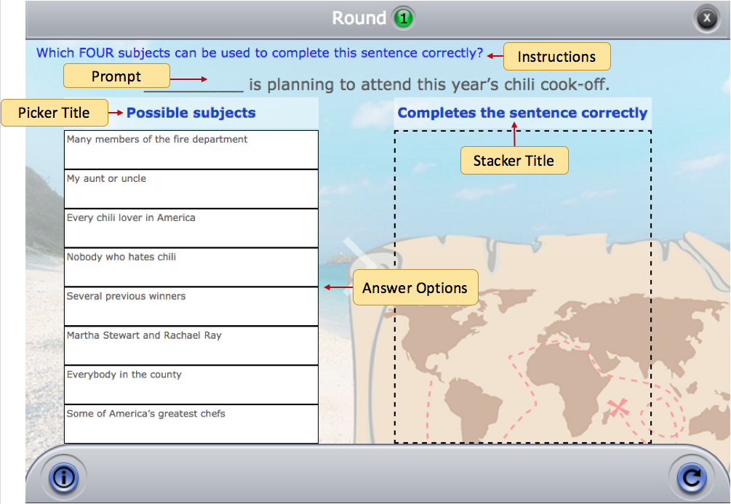

**Instructions:** (Use if the instructions are the same for the entire game)

**Disregard Order:** On/Off (ON = FINDERS KEEPERS, OFF = PICK AND STACK)

Round #

**Instructions:** (Use if the instructions are round specific)

**Prompt:** (Optional -- can be text or image)

**Picker title:** (Title that will appear over the answer options)

**Stacker title:** (Title that will appear over the correct answer box)

**Correct “Pick” Feedback:** (Message displays when all correct answers are selected)

**Correct “Stack” Feedback:** (Message displays when selected answers are stacked in the correct order – for PICK AND STACK only)

**Incorrect “Stack” Feedback:** (General incorrect feedback for when answers are stacked in the wrong order -- for PICK AND STACK only)

**Answer Options**: Enter the correct answers first and then the distractors. If this is PICK AND STACK, enter answers in the order they should be stacked. There is no set number of answer options or correct answers and not all of the cells will necessarily be needed.

|  |  |
| --- | --- |
| **Answer Options** | **Specific “Pick” Incorrect Feedback –** Cells next to correct answers will be blank |
| (Correct answer 1) |  |
| (Correct answer 2) |  |
| (Correct answer 3) |  |
| (Correct answer 4) |  |
| Etc, etc, etc |  |
| (Incorrect answer) | (Incorrect feedback) |
| (Incorrect answer) | (Incorrect feedback) |
| (Incorrect answer) | (Incorrect feedback) |
| (Incorrect answer) | (Incorrect feedback) |
| Etc. etc, etc | (Incorrect feedback) |

**Specific “Stack” Incorrect Feedback:** PICK AND STACK only – Use this table if there is a stack order that will generate specific incorrect feedback. Put each answer on its own line and in the order that will trigger the specific feedback.

|  |  |
| --- | --- |
| **Ordered Answers** | **Specific “Stack” Incorrect Feedback** |
| (Answer 4)  (Answer 1)  (Answer 2)  (Answer 3) | (Specific incorrect feedback) |
| (Answer 2)  (Answer 3)  (Answer 1)  (Answer 4) | (Specific incorrect feedback) |